Aws Task

Step1:

Creating the windows server in Aws and successfully created

Screen shot mentioned below

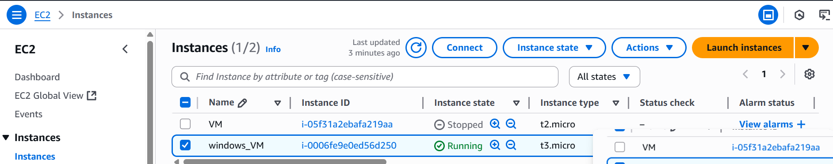

Step 2:

So in the Neworking setting we chosen the RDP and Myip

Screenshot mentioned below

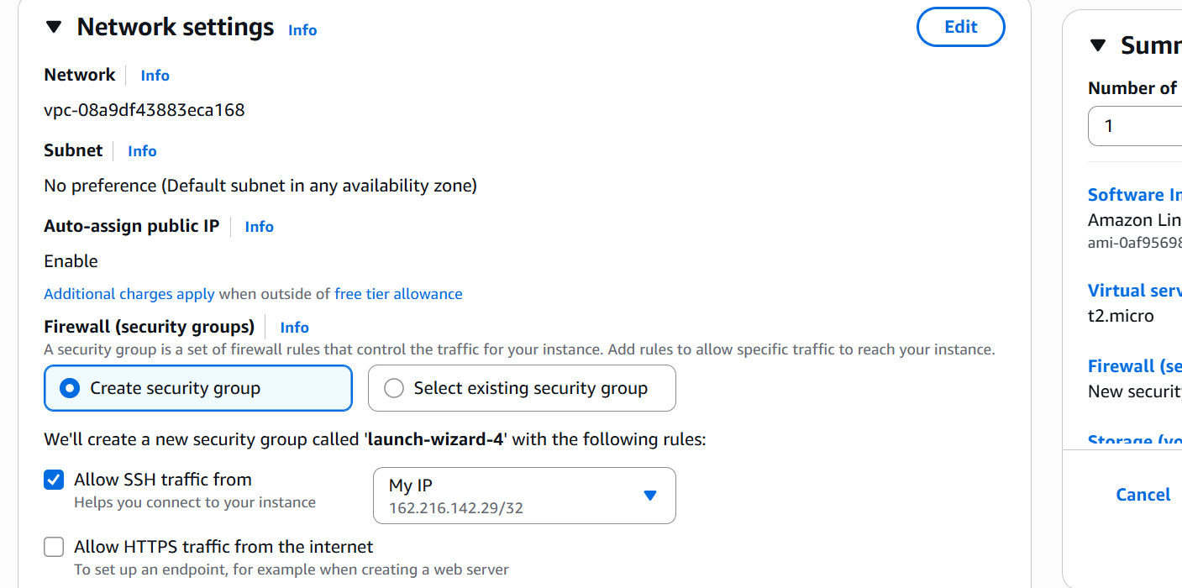

Step3:

Created and use to Connect through the RDP we mentioned the Username and password for that

Goto-> Action -> security ->Get windows password

Screenshot mentioned below

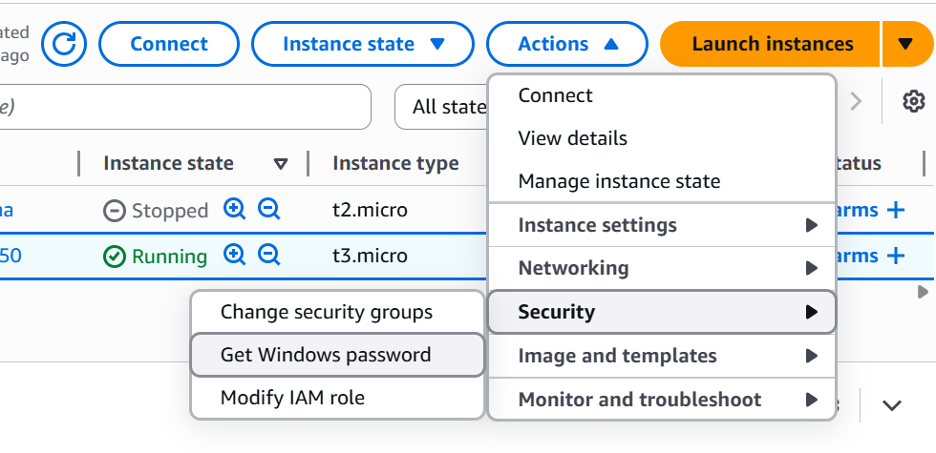

Upload the pem file in the upload section and decrptecd the password

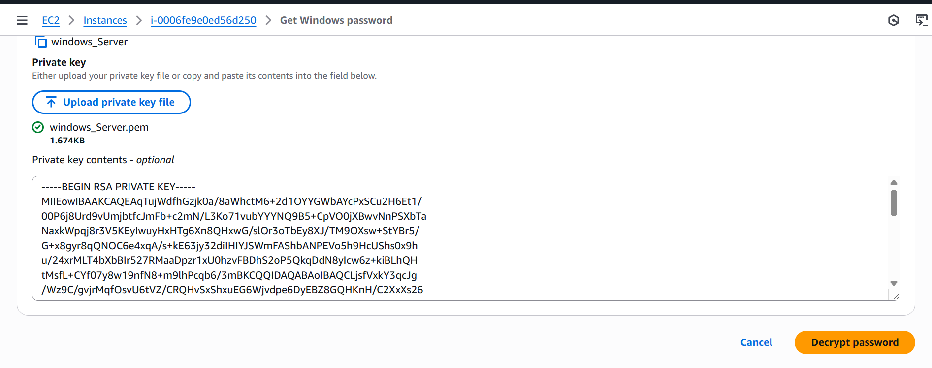

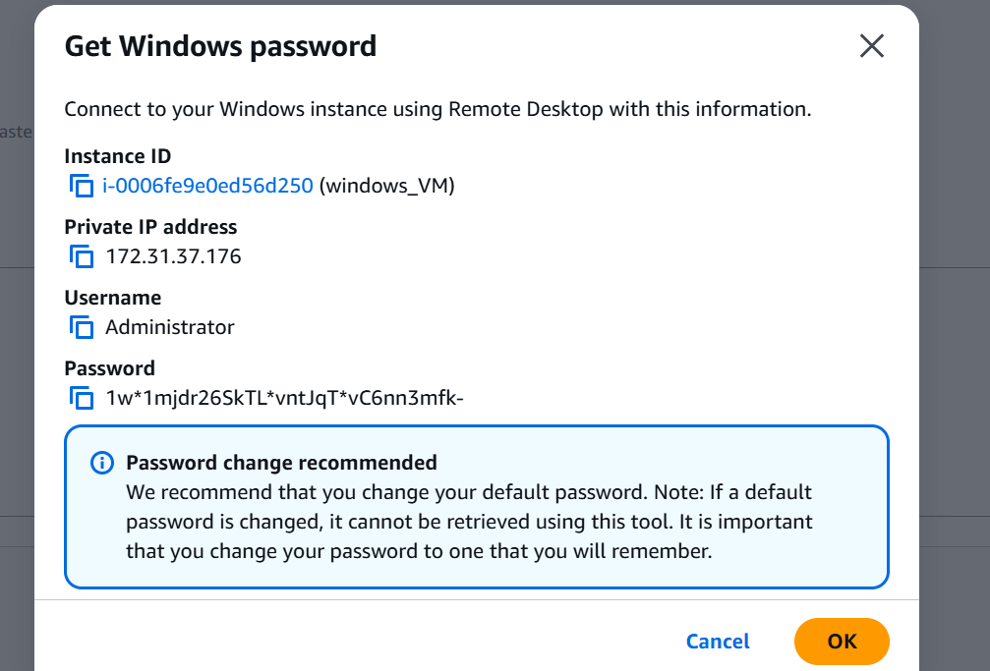

Thereafter if we try to connect with Rdp it works

Its ask for user name and password

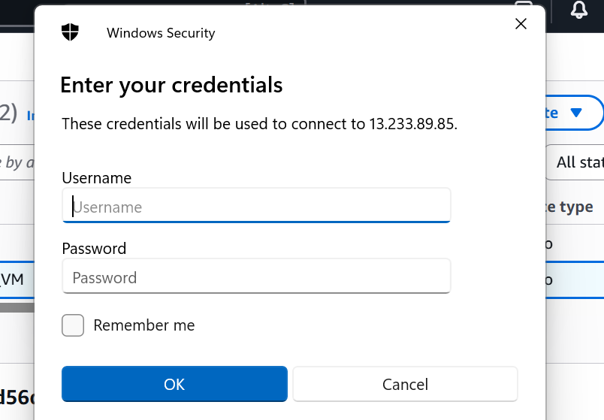

Step 4:

Opening the command promt in created server and using command systeminfo

Screenshot mentioned below:

